***DATA VISUALIZATION USING POWER BI***

1. Enter data-> Base Measure. This will create a new table called base measure. Now add measures within the base measure

* Revenue=sum(‘sales transactions[sales_amount]’)

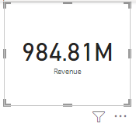

* Quantity=sum('sales transactions[sales_qty]’)

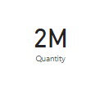

1. Revenue by customers. Drag and drop customer_name field to the X-axis field

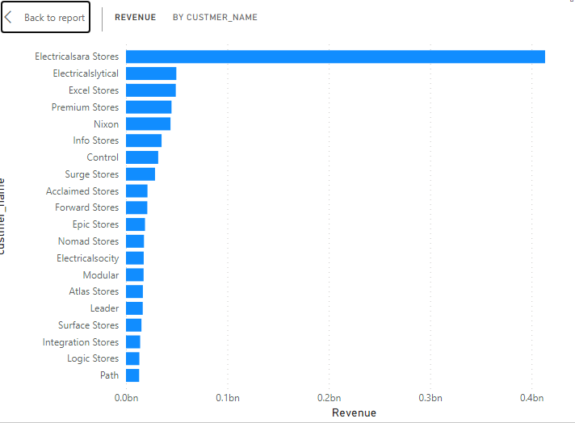

1. Quantity by customers. Drag and drop quantity to x-axis and customer_name to y-axis

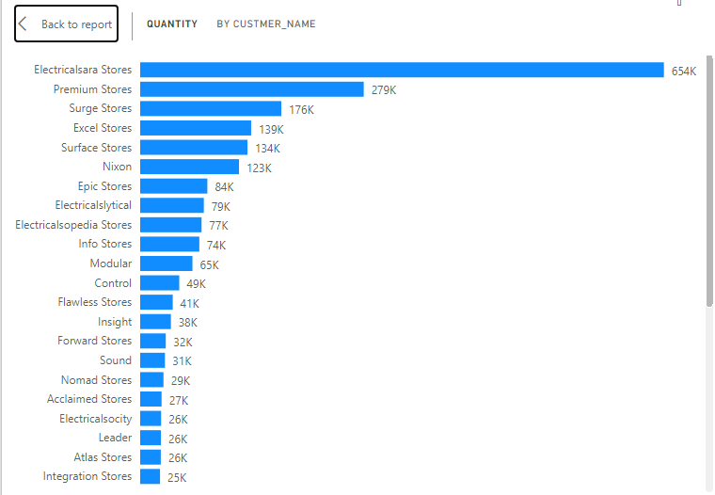

1. Create a slicer with year data from customer.date

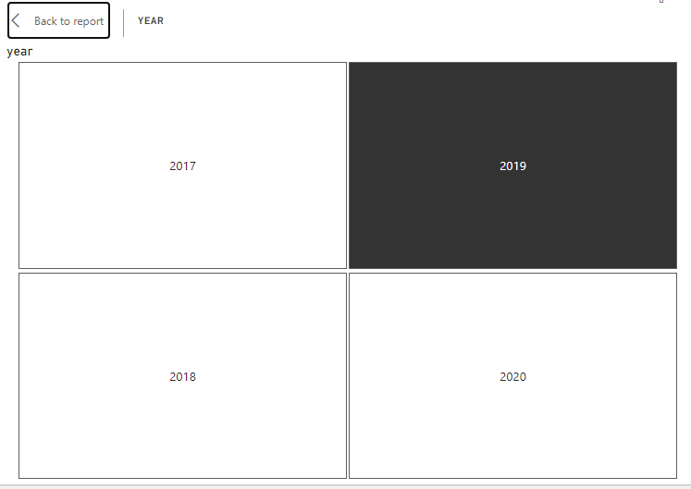

1. Create a slicer for the month names, to have a monthly analysis

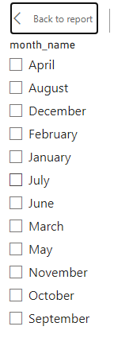

1. Revenue by markets: Add market name from market table to the x-axis

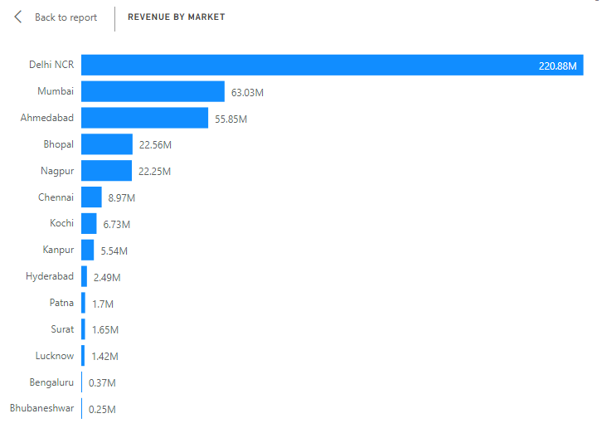

1. Add a line graph to show the revenue by month

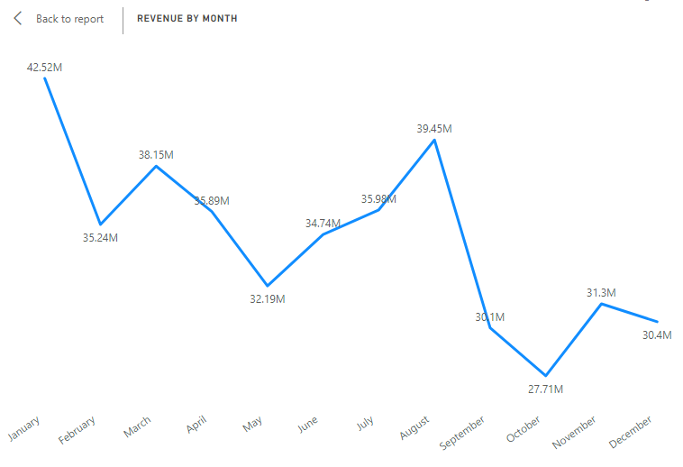

***RESULT:***

